**Exp. No.: 21**

**Date:**

**MYSQL STRING FUNCTIONS- SPACE, SUBSTR, UPPER, LOWER, TRIM, LENGTH**

**AIM:**

To implement Space, Substr, Upper, Lower, Trim, Length String Functions using MySQL.

**SPACE()**

MySQL SPACE() returns the string containing a number of spaces as specified in the argument.  
Syntax : SPACE(N)  
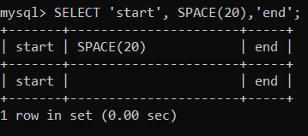

**SUBSTRING() / SUBSTR()**

**MySQL SUBSTRING()** returns a specified number of characters from a particular position of a given string.

Syntax : SUBSTRING(str,pos,len)

**MySQL SUBSTR()** returns the specified number of characters from a particular position of a given string. SUBSTR() is a synonym for SUBSTRING().  
Syntax : SUBSTR(str,pos,len)  
  
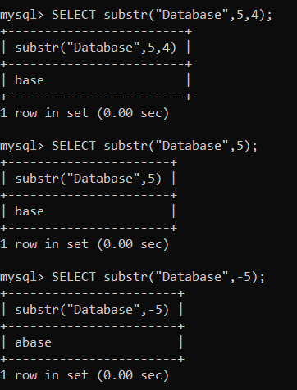

**UPPER()**

MySQL UPPER() converts all the characters in a string to uppercase characters.  
Syntax : UPPER(str)  
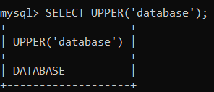

**LOWER() /LCASE()**

MySQL **LCASE()** converts the characters of a string to lower case characters.  
Syntax : LCASE(str)

MySQL **LOWER**() **converts all** the characters in a string to lowercase characters.  
Syntax: **LOWER** (str);  
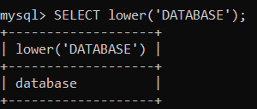

**TRIM()**

MySQL TRIM() function returns a string after removing all prefixes or suffixes from the given string.  
Syntax : TRIM([{BOTH | LEADING | TRAILING} [remstr] FROM] str)  
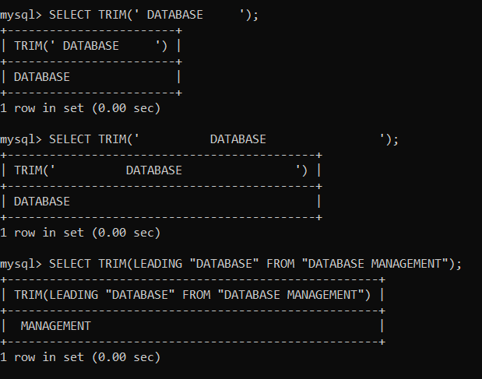

**RTRIM()**

MySQL RTRIM() removes the trailing spaces from a given string.  
Syntax : RTRIM(str)  
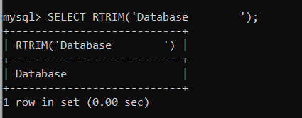

**LTRIM(str)**

MySQL LTRIM() removes the leading space characters of a string passed as argument.  
Syntax : LTRIM(str)  
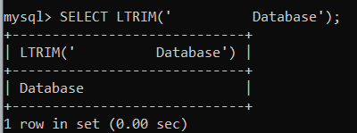

**LENGTH()**

MySQL LENGTH() returns the length of a given string.  
Syntax : LENGTH(str)  
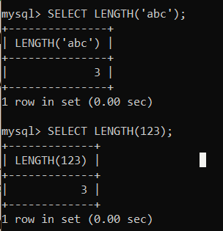

**BIT_LENGTH()**

Returns the length of the string str in bits.  
Syntax : BIT_LENGTH(str)  
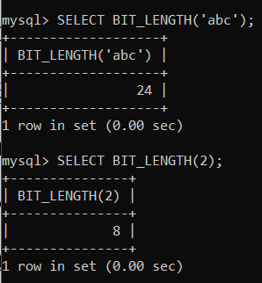

**CHAR_LENGTH()**

Returns the length of the string str, measured in characters. A multi-byte character counts as a single character. This means that for a string containing five 2-byte characters, LENGTH() returns 10, whereas CHAR_LENGTH() returns 5.  
Syntax : CHAR_LENGTH(str)  
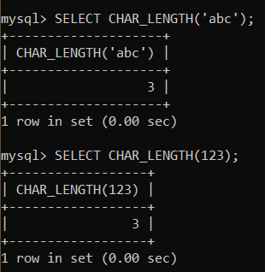

**CONCAT()**

Returns the string that results from concatenating one or more arguments. If all arguments are nonbinary strings, the result is a nonbinary string. If the arguments include any binary strings, the result is a binary string. A numeric argument is converted to its equivalent nonbinary string form.  
Syntax : CONCAT(str1,str2,...)  
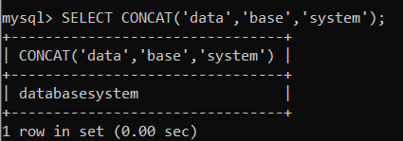

**INSTR()**

MySQL INSTR() takes a string and a substring of it as arguments, and returns an integer which indicates the position of the first occurrence of the substring within the string  
Syntax : INSTR(str,substr)  
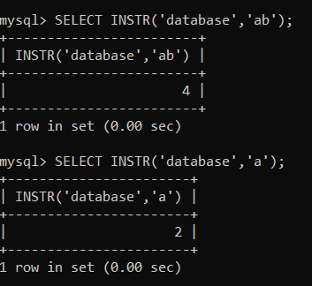

**LOCATE()**

MySQL LOCATE() returns the position of the first occurrence of a string within a string. Both of these strings are passed as arguments. An optional argument may be used to specify from which position of the string (i.e. string to be searched) searching will start. If this position is not mentioned, searching starts from the beginning.  
Syntax : LOCATE(substr,str,pos)  
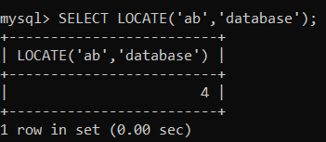

**MID()**

MySQL MID() extracts a substring from a string. The actual string, position to start extraction and length of the extracted string - all are specified as arguments.  
Syntax : MID(str,pos,len)  
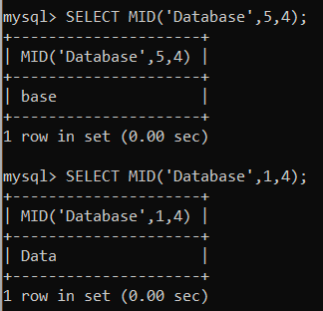

**POSITION()**

MySQL POSITION() returns the position of a substring within a string..  
Syntax : POSITION(substr IN str)  
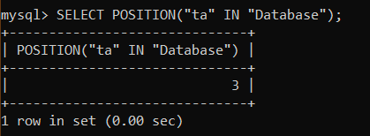

**RESULT:** Thus the String Functions such as space, substr, upper, lower, trim, length are executed successfully.